视频P45〜P46：https://www.bilibili.com/video/BV18L4y1M7Bd?p=45

责任链模式

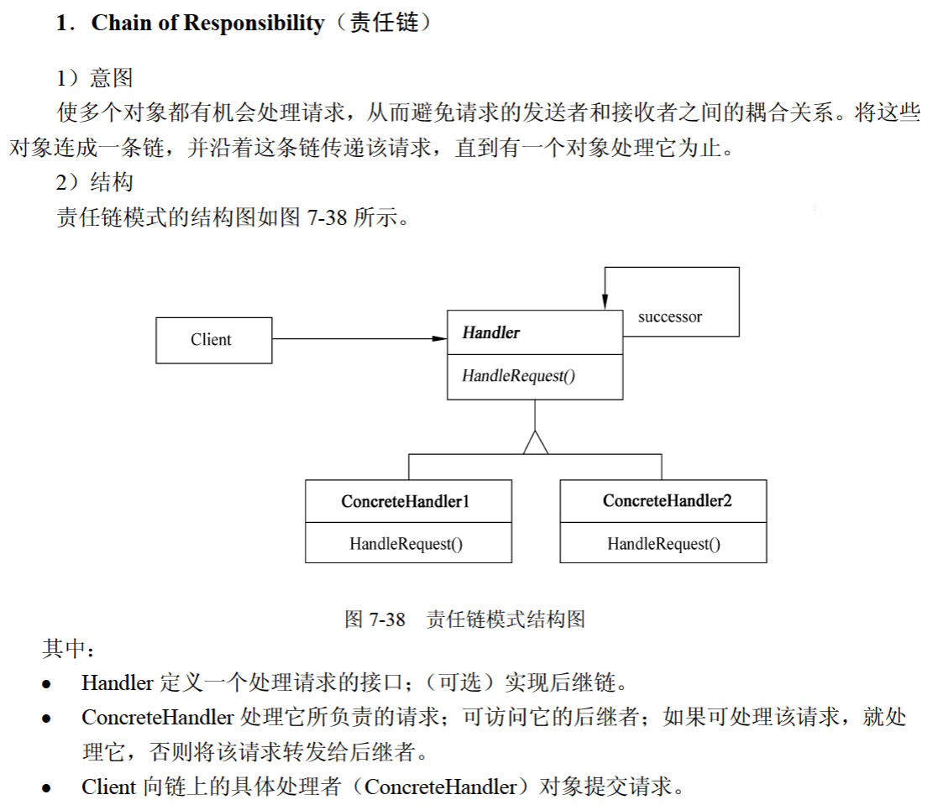
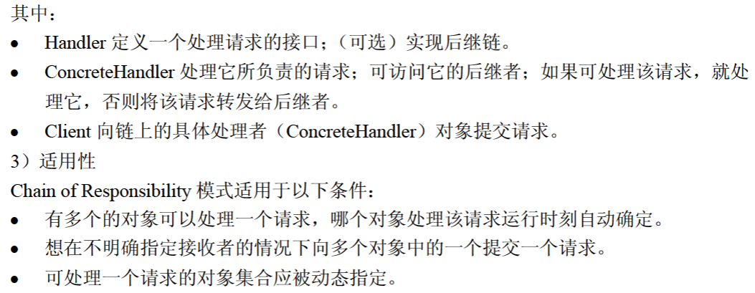

代码
public class ChainOfResponsibilityPattern {
public static void main(String[] args) {
Handler fudaoyuan = new FuDaoYuan();
Handler yuanzhang = new YuanZhang();
Handler xiaozhang = new XiaoZhang();

fudaoyuan.setNext(yuanzhang);
yuanzhang.setNext(xiaozhang);

fudaoyuan.HandlerRequest(31);
}
}

abstract class Handler {
protected Handler next;

public void setNext(Handler next) {
this.next = next;
}

public abstract void HandlerRequest(int request);
}

class FuDaoYuan extends Handler { // <= 7 审批

@Override
public void HandlerRequest(int request) {
if (request <= 7) {
System.out.println("辅导员审批通过");
} else {
if (next != null) {
next.HandlerRequest(request);
} else {
System.out.println("无法审批");
}
}
}
}

class YuanZhang extends Handler { // <= 15 审批

@Override
public void HandlerRequest(int request) {
if (request <= 15) {
System.out.println("院长审批通过");
} else {
if (next != null) {
next.HandlerRequest(request);
} else {
System.out.println("无法审批");
}
}
}
}

class XiaoZhang extends Handler { // <= 30 审批

@Override
public void HandlerRequest(int request) {
if (request <= 30) {
System.out.println("校长审批通过");
} else {
if (next != null) {
next.HandlerRequest(request);
} else {
System.out.println("无法审批");
}
}
}
}

