2016年下半年试题六
阅读下列说明和Java代码，将应填入 （n） 处的字句写在答题纸的对应栏内。
【说明】
某发票（lnvoice）由抬头（Head）部分、正文部分和脚注（Foot）部分构成。现采用装饰（Decorator）模式实现打印发票的功能，得到如图6-1所示的类图。
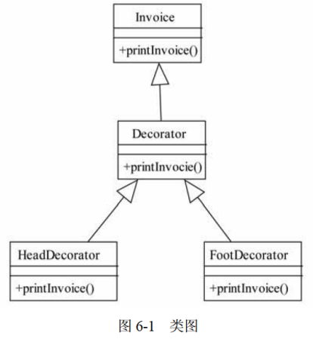
【java代码】
class invoice {
public void printInvoice() {
System.out.println("This is the content of the invoice!");
}
}

class Decorator extends Invoice {
protected Invoice ticket;
public Decorator(Invoice t) {
ticket = t;
}
public void printInvoice() {
if (ticket != null)
(1) ;
}
}

class HeadDecorator extends Decorator {
public HeadDecorator(Invoice t) {
super(t);
}
public void printInvoice () {
System.out.println("This is the header of the invoice!");
(2) ;
}
}

class FootDecorator extends Decorator {
public FootDecorator(Invoice t) {
super(t);
}
public void printInvoice() {
(3) ;
System.out.println("This is the footnote of the invoice!");
}
}
class Test {
public static void main(String[] args) {
Invoice t = new Invoice();
Invoice ticket;
ticket = (4) ;
ticket.printInvoice();
System.out.println("--------------------");
ticket = (5) ;
ticket.printInvoice();
}
}

程序的输出结果为：
This is the header of the invoice!
This is the content of the invoice!
This is the footnote of the invoice!
--------------------
This is the header of the invoice!
This is the footnote of the invoice!

解析在下一页！

视频解析P32：https://www.bilibili.com/video/BV1XT4y1v7ih?p=32

文字解析：下方
