python+requests+pytest接口自动化介绍

1.发送get请求
#导包
import requests
#定义一个url
url = "http://xxxxxxx"
#传递参数
payload="{\"head\":{\"accessToken\":\"\",\"lastnotice\":0,\"msgid\":\"\"},\"body\":{\"user_name\":\"super_admin\",\"password\":\"b50c34503a97e7d0d44c38f72d2e91ad\",\"role_type\":1}}"
headers = {
'Content-Type': 'text/plain',
'Cookie': 'akpsysessionid=bafc0ad457d5a99f3a4e53a1d4b32519'
}
#发送get请求
r = requests.get( url=url,headers=headers, data=payload)
#打印结果
print(r.text)
#解码
print(r.encoding)
print(r.text.encode('utf-8').decode('unicode_escape'))#先把返回的结果转换成utf-8，再去解码成中文的编码
2.发送post请求
#导包
import requests
#定义一个url
url = "http://xxxxxxx"
#传递参数
payload="{\"head\":{\"accessToken\":\"\",\"lastnotice\":0,\"msgid\":\"\"},\"body\":{\"user_name\":\"super_admin\",\"password\":\"b50c34503a97e7d0d44c38f72d2e91ad\",\"role_type\":1}}"
headers = {
'Content-Type': 'text/plain',
'Cookie': 'akpsysessionid=bafc0ad457d5a99f3a4e53a1d4b32519'
}
#发送post请求
r = requests.post( url=url,headers=headers, data=payload)
#打印结果
print(r.text)
3.发送https请求
import requests
url='https://www.ctrip.com/'
#第一种解决方案，发送请求的时候忽略证书，证书的参数verify用的比较多
r=requests.post(url=url,verify=False)#verify参数默认为True，值为False，表示忽略证书
#第二张解决方案，verify里面添加证书的路径
r=requests.post(url=url,verify='证书的路径')#verify参数默认为True，值为False，表示忽略证书
print(r.text)
4.文件上传
import requests
file = {
'filename':open('文件名称','rb')
}
response = requests.post("网址",file)
print(response.text)
5.文件下载
#小文件下载
import requests
r = requests.get("https://img.sitven.cn/Tencent_blog_detail.jpg")
with open(r"D:\a.jpg", "wb") as f:
f.write(r.content)
#大文件下载
import requests
def test_downloads(url, file):
s = requests.session()
r = s.get(url, stream=True, verify=False)
with open(file, "wb") as f:
for chunk in r.iter_content(chunk_size=512):
f.write(chunk)
if __name__ == "__main__":
url = "https://www.url.com/test/export"
file = "D:\\a.xlsx"
test_downloads(url=url, file=file)
#转载至：https://blog.csdn.net/weixin_43507959/article/details/107326912
6.timeout超时
#导包
import requests
#循环10次
for i in range(0,10):
try:
url="http://xxxxxxxxxxxxxxxx"
data={
"head":{"lastnotice":0,"msgid":"","accessToken":"89a08bff-15d7-4d7a-9967-0b5f4fb699ce"},
"body":{"clinicid":"978f661e-1782-43bd-8675-b0ff1138ab7c","deptid":"09b8515b-b01b-4771-9356-aed6b5aa01bf","doctorid":"65ac0251-10ff-473a-af8a-20e8969176f7","registtype":0,"card_num":"","bcc334":"","patientopt":1,"bkc368":"1","patient":{"cardid":"","medicalcardid":"","label":"","sourcetype":1,"nationid":"01","maritalstatus":0,"address":"","company":"","jobname":"","email":"","remark":"","bcc334":"","name":"11","gender":1,"phone":"","birthdate":"2020-03-23","patienttype":1,"szsbcardid":""}}
}
#发送post请求，超时时间0.03s
r=requests.post(url=url,json=data,timeout=0.03)
print(r.text)
print(r.cookies)
except:
print('error')
#可参考：https://blog.csdn.net/weixin_44350337/article/details/99655387
7.鉴权
7.1 auth参数鉴权
import requests
url = 'http://192.168.1.1'
headers = {} # 有的不带头也能请求到 不带头可以忽略这行 和headers=headers,这两处
r = requests.get(url, auth=('admin', '123456'), headers=headers, timeout=10)
print(r.text)
7.2 session操作
#实例化session
session = requests.session()
#使用session发起请求
response = session.post(url,headers=req_header,data=form_data)
7.3 token操作
import requests
url="http://xxxxxxxxxxxxxxx"
json={
"head":{"accessToken":"","lastnotice":0,"msgid":""},
"body":{"username":"15623720880","password":"48028d2558577c526a017883211b4066","forceLogin":0}
}
r=requests.post(url=url,json=json)
print(r.text)
print(r.cookies)
#登录成功后返回token，带入下一个接口
for i in range(0,1):
try:
url="xxxxxxxxxxxxxxxxxx"
data={
"head":{"lastnotice":0,"msgid":"","accessToken":"89a08bff-15d7-4d7a-9967-0b5f4fb699ce"},
"body":{"clinicid":"978f661e-1782-43bd-8675-b0ff1138ab7c","deptid":"09b8515b-b01b-4771-9356-aed6b5aa01bf","doctorid":"65ac0251-10ff-473a-af8a-20e8969176f7","registtype":0,"card_num":"","bcc334":"","patientopt":1,"bkc368":"1","patient":{"cardid":"","medicalcardid":"","label":"","sourcetype":1,"nationid":"01","maritalstatus":0,"address":"","company":"","jobname":"","email":"","remark":"","bcc334":"","name":"11","gender":1,"phone":"","birthdate":"2020-03-23","patienttype":1,"szsbcardid":""}}
}
r=requests.post(url=url,json=data,timeout=0.09)
print(r.text)
print(r.cookies)
except:
print('error')
7.4 sign签名
# appid：wxd930ea5d5a258f4f
# mch_id：10000100
# device_info：1000
# body：test
# nonce_str：ibuaiVcKdpRxkhJA
import hashlib
#需要加密的字符串
stringA="appid=wxd930ea5d5a258f4f&body=test&device_info=1000&mch_id=10000100&nonce_str=ibuaiVcKdpRxkhJA";
#构建一个对象为md
md=hashlib.md5()
#对stringA字符串进行编码
md.update(stringA.encode())
#生成后的加密值
AES=md.hexdigest()
#把加密的结果，小写转大写 upper函数
AES=AES.upper()
print(AES)
参考微信支付：https://pay.weixin.qq.com/wiki/doc/api/jsapi.php?chapter=4_3
8.自动化模块划分
config 配置文件（python package）#directory和python package大同小异
common 公共的方法（python package）
testdata 测试数据（python package）
test_case测试用例（python package）
report 报告（directory）
run_case 测试执行（python package）
log 日志
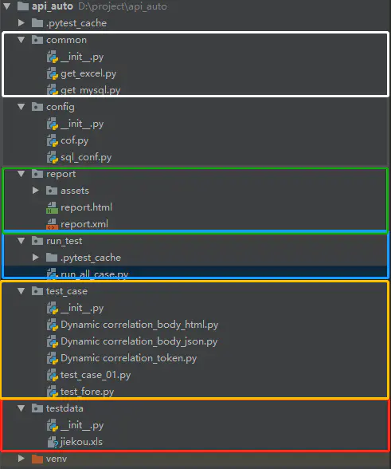
8.1 config配置文件
def server_ip():
'''
ait_ip=''开发环境的服务器ip
sit_ip=''测试环境的服务器ip
:return: 返回不同服务器的地址
'''
server_add={
'dev_ip' : 'http://his.xxxxxxxxxxx.com',
'sit_ip' : 'http://his.xxxxxxxxxxxx.comm'
}
return server_add['dev_ip']
------------------------------------------------------------------------------------
def sql_conf():
'''
host数据库ip
user数据库用户名
password数据库密码
database:连接数据库名
port数据库端口
chrset数据库字符集 中文utf-8
:return:
'''
host='localhost'
user='root'
password='123456'
database='mysql'
port=3306
charset='utf8' #这用utf8，utf-8会报错
return host,user,password,database,port,charset
8.2 common 公共的方法
# 封装一个读取Excel表格数据的函数
# 对Excel表格数据的读取需要用到一个库——xlrd库
import xlrd
def get_excel_value(i):
'''
读取表中一行的数据
:return:返回2，3行数据
'''
filename = r"../testdata/jiekou.xls" #文件要用相对路径
book = xlrd.open_workbook(filename) # 打开一个工作薄，不需要手动进行关闭
# sheet = book.sheet_by_name("Sheet1") 根据工作表的名字，获取一个工作表对象
sheet = book.sheet_by_index(0) # 获取一个工作表，以index的方式，这里是获取第1个工作表
return sheet.cell_value(i,1),sheet.cell_value(i,2)
# print(sheet.nrows) #打印所有行
# print(sheet.ncols) #打印所有列
# print(sheet.row_values(0)) #打印第一行
# print(sheet.col_values(0)) #打印第一列
# print(sheet.cell_value(0,1)) #打印第一行，第二列
# for i in range(1, sheet.nrows):
# print(sheet.cell_value(i,1),sheet.cell_value(i,2))# 打印单元格[所有数据]的值
# str='(sheet.cell_value(i,1),sheet.cell_value(i,2)))'
# print(str)
# for i in range(1, sheet.nrows):
# # for j in range(0, sheet.ncols):
# print(sheet.cell_value(i,j)) # 打印单元格[i,j]的值
---------------------------------------------------------------------------------------------
import pymysql
from config.sql_conf import *
def get_sql(sql):
'''
:param sql:运行查询的sql语句
:return:数据库查询结果
'''
#建立一个连接对象
host, user, password, database, port, charset=sql_conf()
db=pymysql.connect(host=host,user=user,password=password,database=database,port=port,charset=charset)
#建立一个游标
cursor=db.cursor()
#执行sql语句
cursor.execute(sql)
#把sql运行的数据保存在data变量里面
data=cursor.fetchall() #获取查询出的所有的值
cursor.close() #关闭游标
db.close() #关闭数据库连接
return data
# print(get_sql("SELECT help_topic_id FROM help_topic WHERE Name='MOD'")) #执行sql语句
# print(type(get_sql("SELECT help_topic_id FROM help_topic WHERE Name='MOD'")))
8.3 estdata 测试数据
主要存放xls，txt，csv测试数据
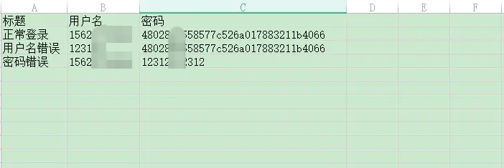
8.4 test_case测试用例
from common.get_mysql import get_sql
from config.cof import server_ip
from common.get_excel import *
from config.sql_conf import *
import requests
# user_id=get_sql("SELECT help_topic_id FROM help_topic WHERE Name='MOD'")#提取数据库数据
# print(user_id)#打印结果
# assert get_sql("SELECT help_topic_id FROM help_topic WHERE Name='MOD'")#断言数据库的数据是否存在
def test_aokao_login():
url=server_ip()+'/service/user/login'
username,password=get_excel_value(1) #读取文件第二行数据
json={
"head":{"accessToken":"","lastnotice":0,"msgid":""},
"body":{"username":username,"password":password,"forceLogin":0}
}
# usernamepassword=get_excel_value(4)[0] #读取文件第二行数据
# print(type(usernamepassword))
# #把str类型转为字典格式 eval 函数
# json=eval(usernamepassword)
r=requests.post(url=url,json=json)
print(r.text)
assert r.status_code==200 #断言状态码是否等于200
assert '"accessToken":"89a08bff-15d7-4d7a-9967-0b5f4fb699ce",' in r.text #断言返回信息是否包含accesstoken
def test_aokao_registadd():
url = server_ip()+'/service/registration/registadd'
data = {
"head": {"lastnotice": 0, "msgid": "", "accessToken": "89a08bff-15d7-4d7a-9967-0b5f4fb699ce"},
"body": {"clinicid": "978f661e-1782-43bd-8675-b0ff1138ab7c", "deptid": "09b8515b-b01b-4771-9356-aed6b5aa01bf",
"doctorid": "65ac0251-10ff-473a-af8a-20e8969176f7", "registtype": 0, "card_num": "", "bcc334": "",
"patientopt": 1, "bkc368": "1",
"patient": {"cardid": "", "medicalcardid": "", "label": "", "sourcetype": 1, "nationid": "01",
"maritalstatus": 0, "address": "", "company": "", "jobname": "", "email": "",
"remark": "", "bcc334": "", "name": "11", "gender": 1, "phone": "",
"birthdate": "2020-03-23", "patienttype": 1, "szsbcardid": ""}}
}
r = requests.post(url=url, json=data, timeout=0.09)
print(r.text)
print(r.cookies)
assert r.status_code == 200 # 断言状态码是否等于200
8.5 report 报告
主要存放html，xml报告
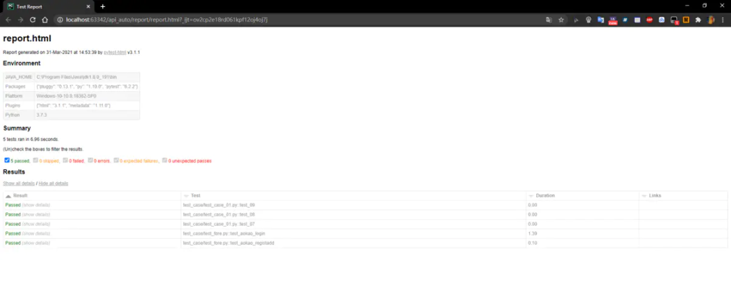
8.6 run_case 测试执行
import pytest
'''
测试文件以test_开头，（以—_test结尾也可以）
测试类以Test开头，并且不能带有init 方法
测试函数以test_开头
断言使用基本的assert即可
'''
#如何去运行测试用例，_test开头的函数就可以，判断用例运行是否成功，assert断言
if __name__=="__main__":
#单个文件运行，运行添加，对应的文件路径，路径要用相对路径
# pytest.main(['../test_case//test_case_01.py'])
#多个文件运行，运行添加多个对应的文件路径，列表的形式，去添加多个文件的路径
# pytest.main(['../test_case/test_fore.py','../test_case/Dynamic correlation_token.py'])
#运行整个目录，添加目录的路径
pytest.main(['../test_case/','--html=../report/report.html','--junitxml=../report/report.xml'])
'''
pytest生成报告：
1、生成html报告
'--html=../report/report.html'
2、生成xml报告
'--junitxml=../report/report.xml'
'''

