OPendaylight + Mininet Installation guide
作者：SDN QQ群#加州旅馆

- Download Opendaylight from the official home page
http://www.opendaylight.org/software/downloads

I downloaded the Zip File, you can choose Virtual Machine if you wish.
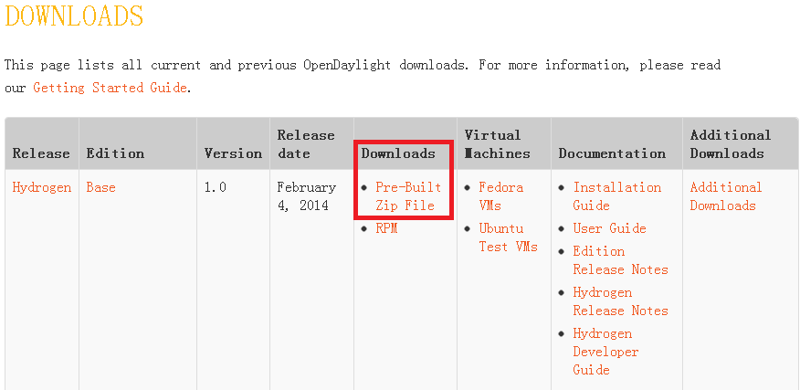
- Install Ubuntu , Version 12.04.4 -64bit (Pass)
- Install opendaylight
- Download source code package------ distributions-base-0.1.1-osgipackage.zip, drag it into the VM (have install VMware Tool).
- Unzip ------ distributions-base-0.1.1-osgipackage.zip
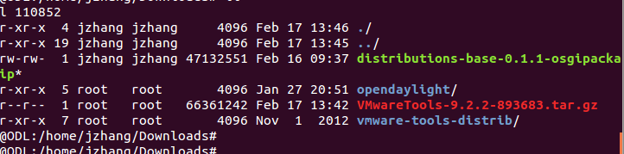
- cd opendaylight/
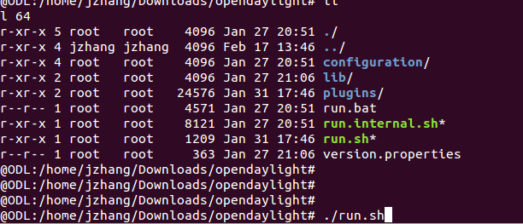

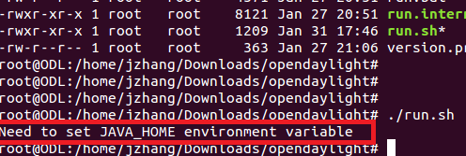
- 配置163更新源：
vim /etc/apt/sources.list
deb http://mirrors.163.com/ubuntu/ precise main restricted
deb-src http://mirrors.163.com/ubuntu/ precise main restricted
deb http://mirrors.163.com/ubuntu/ precise-updates main restricted
deb-src http://mirrors.163.com/ubuntu/ precise-updates main restricted
deb http://mirrors.163.com/ubuntu/ precise-updates universe
deb-src http://mirrors.163.com/ubuntu/ precise-updates universe
deb http://mirrors.163.com/ubuntu/ precise multiverse
deb-src http://mirrors.163.com/ubuntu/ precise multiverse
deb http://mirrors.163.com/ubuntu/ precise-updates multiverse
deb-src http://mirrors.163.com/ubuntu/ precise-updates multiverse
deb http://mirrors.163.com/ubuntu/ precise-backports main restricted universe multiverse
deb-src http://mirrors.163.com/ubuntu/ precise-backports main restricted universe multiverse
deb http://mirrors.163.com/ubuntu/ precise-security main restricted
deb-src http://mirrors.163.com/ubuntu/ precise-security main restricted
deb http://mirrors.163.com/ubuntu/ precise-security universe
deb-src http://mirrors.163.com/ubuntu/ precise-security universe
deb http://mirrors.163.com/ubuntu/ precise-security multiverse
deb-src http://mirrors.163.com/ubuntu/ precise-security multiverse
deb http://extras.ubuntu.com/ubuntu precise main
deb-src http://extras.ubuntu.com/ubuntu precise main
install OpenJDK-7
delete jdk6 first
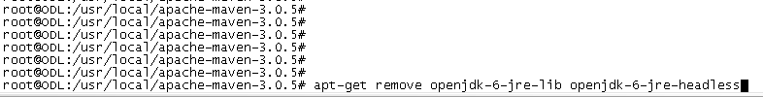
Install Openjdk-7
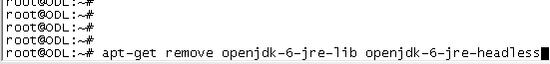

Add environment parameters
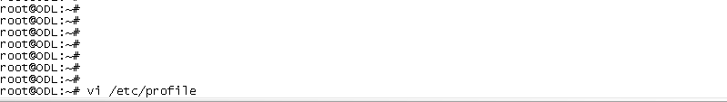

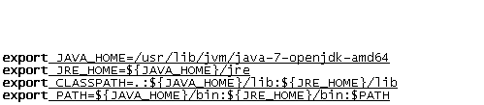

Reboot system

Run Opendaylight ./run.sh
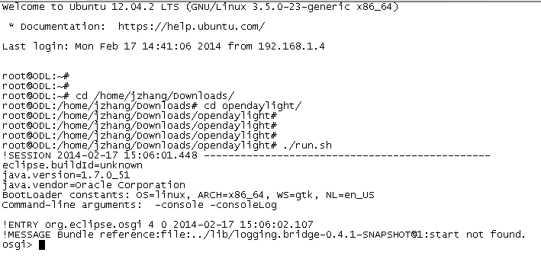

http://192.168.1.5:8080

Username:admin
Password:admin

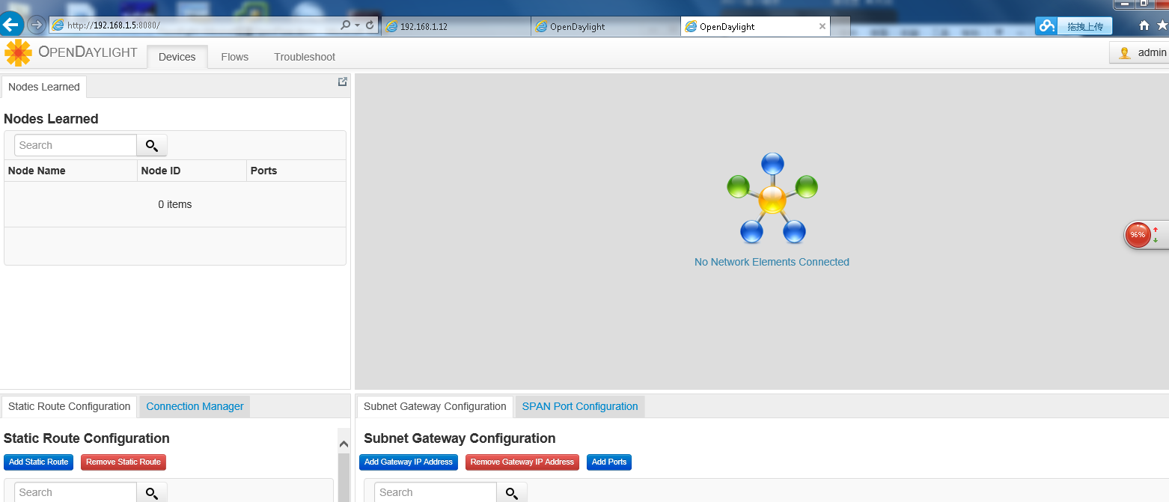

Mininet installation

1 To install natively from source, first you need to get the source code
git clone git://github.com/mininet/mininet
2 Note that the above git command will check out the latest and greatest Mininet (which we recommend!) If you want to run the last tagged/released version of Mininet, use:
git clone git://github.com/mininet/mininet
git checkout -b 2.1.0p1 2.1.0p1
Once you have the source tree, the command to install Mininet is:
mininet/util/install.sh

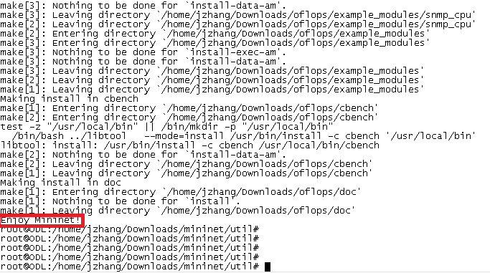

Command summary:
git clone git://github.com/mininet/mininet
apt-get install git
git clone git://github.com/mininet/mininet
git checkout -b 2.1.0p1 2.1.0p1
cd mininet/
cd util/
./install.sh

mn --controller=remote,ip=192.168.1.6 –custom /home/jzhang/Downloads/mininet/custom/topo-2sw-2host.py --topo mytopo --mac

